Keybindings for macros
 |  |  | keyboard | macro
Alt(%) | 5 |  | x | x | $$Repeating digit$$
Alt | 6 |  | x | X | $$Radical$$
Alt | 7 |  | x | X | $$Exponent$$
Alt | 8 |  | x | x | $$Brackets$$
Alt | 9 |  | x | x | $$Reciprocal$$
Alt | 0 |  | x | x | $$Fraction$$
Alt | E |  | x | x | $$Not_equal$$
Alt | T |  | x | x | $$Approximate$$
Alt | U |  | x | x | $$Plus_or_Minus$$
Alt | I |  | x | x | $$Absolute_value$$
Alt | O |  | x | X | $$Greater_than$$
Alt | A |  | x | x | $$Less_than$$
Alt | D |  | x | x | $$Greater_or_equal$$
Alt | K |  | x | x | $$Less_or_equal$$
Alt | X |  | x | X | $$Square_bracket$$
Alt | C |  | x | x | $$Curly_bracket$$
Alt | V |  | x | x | $$logarithm$$
Alt | B |  | x | x | subscript
Ctrl(^) | Alt(%) | 4 | x | x | $$Degree$$
Ctrl | Alt | 5 | x | x | mu
Ctrl | Alt | 6 | x | x | $$Pi$$
Ctrl | Alt | 7 | x | x | $$Infinity$$
Ctrl | Alt | 8 | x | x | $$Angle$$
Ctrl | Alt | 9 | x | x | $$Arrow right$$
Ctrl | Alt | 0 | x | x | $$Sine$$
Ctrl | Alt | Q | x | x | $$Cosine$$
Ctrl | Alt | W | x | x | $$Tangent$$
Ctrl | Alt | A | x | x | $$Cotangent$$
Ctrl | Alt | G | x | x | $$Cosecant$$
Ctrl | Alt | H | x | x | $$Secant$$
Ctrl | Alt | J | x | x | $$Theta$$
Ctrl | Alt | X | x | x | omega
Ctrl | Alt | B | x | x | $$Ceiling function$$
Ctrl | 1 |  | x | x | $$Floor function$$
Ctrl | 3 | x | x | X | $$Quadratic equations$$
Ctrl | 4 | x | x | x | $$Pythagorean theorem$$
Ctrl | 6 |  | x | X | $$Binomial rule$$
Ctrl | 7 |  | x | X | $$Binomial rule factored$$
Ctrl | 8 |  | x | x | $$Function of$$
Ctrl | 9 |  | x |  | Sigma
Ctrl | T |  | x |  | Delta
Alt(%) | Shift(+) | 5 | x |  | Integral
Alt | Shift | 6
Alt | Shift | 7
Alt | Shift | 8
Alt | Shift | 9
Alt | Shift | 0
Alt | Shift | E
Alt | Shift | T
Alt | Shift | U
Alt | Shift | I
Alt | Shift | O
Alt | Shift | A
Alt | Shift | D
Alt | Shift | K
Alt | Shift | X
Alt | Shift | C
Alt | Shift | V
Alt | Shift | B
Ctrl(^) | Alt(%) | Shift(^) | 4
Ctrl | Alt | Shift | 5
Ctrl | Alt | Shift | 6
Ctrl | Alt | Shift | 7
Ctrl | Alt | Shift | 8
Ctrl | Alt | Shift | 9
Ctrl | Alt | Shift | 0
Ctrl | Alt | Shift | Q
Ctrl | Alt | Shift | W
Ctrl | Alt | Shift | A
Ctrl | Alt | Shift | G
Ctrl | Alt | Shift | H
Ctrl | Alt | Shift | J
Ctrl | Alt | Shift | X
Ctrl | Alt | Shift | B
Ctrl | Shift | 1
Ctrl | Shift | 3
Ctrl | Shift | 4
Ctrl | Shift | 6
Ctrl | Shift | 7
Ctrl | Shift | 8
Ctrl | Shift | 9
Ctrl | Shift | T

http://cespage.com/vb/vb08tut21.html

for keyboard codes,
use “+” for shift
use ”%” for alt
use “^” for control
You will create an On-Screen Keyboard which lists all the Windows on your Computer and allows you to type into those using the Application with a bit of help from functionality available in Windows.
Printer Friendly Download Tutorial (239KB) Download Source Code (13.7KB)
Step 1
Start Microsoft Visual Basic 2008 Express Edition, then select File then New Project... Choose Windows Forms Application from the New Project Window, enter a name for the Project and then click OK, see below:
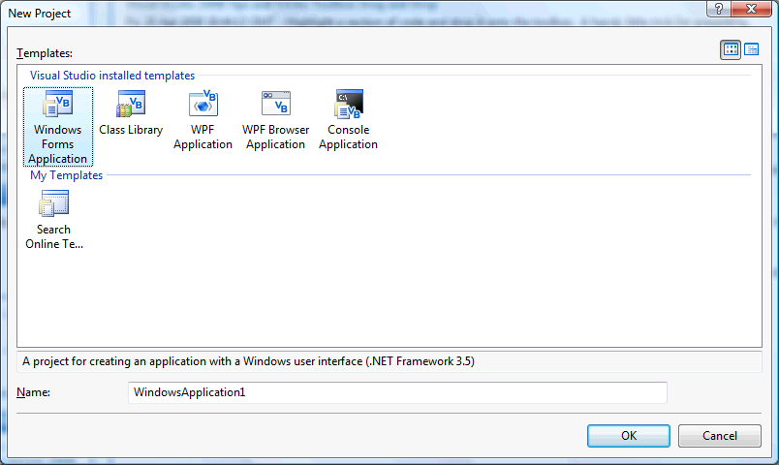
Step 2
A Blank Form named Form1 should then appear, see below:
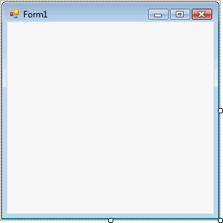
Step 3
With Form1 selected go to the Properties box and change the following
Under the Design submenu, change the Name from Form1 to frmMain
Under the Appearance submenu, change the FormBorderStyle to FixedToolWindow.
Under layout submenu, change Size to "1936, 181" and Text to "Keyboard" both without the quotes and then set TopMost to True. Size is under the layout menu….
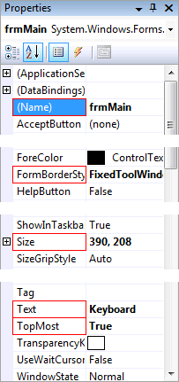
Step 4
Then from the Common Controls tab on the Toolbox select the ComboBox component:
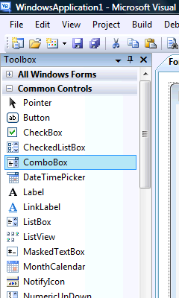
Step 5
Draw a ComboBox on the Form, see below:
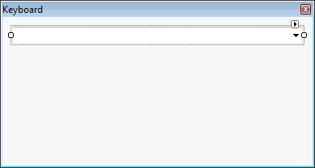
Step 6
Select or click on the ComboBox, then go to the Properties box and change the following;
Under the Design submenu, change Name to cboWindows
Under the appearance submenu, change the DropDownStyle to DropDownList, see below:
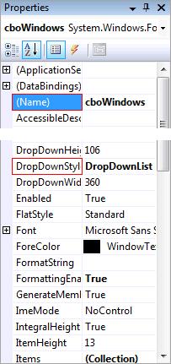
Step 7
Right Click on the Form or the entry of the Form in Solution Explorer and choose the "View Code" option, delete all code in the terminal and enter the following;

Public Class frmMain

' API Methods

Public Declare Function IsWindowVisible Lib "user32.dll" _
Alias "IsWindowVisible" (ByVal hwnd As Integer) As Boolean

Public Declare Function GetWindow Lib "user32.dll" _
Alias "GetWindow" (ByVal hwnd As Integer,
ByVal wCmd As Integer) As Integer

Public Declare Function GetWindowLong Lib "user32.dll" _
Alias "GetWindowLongA" (ByVal hwnd As Integer,
ByVal nIndex As Integer) As Integer

Public Declare Function GetParent Lib "user32.dll" _
Alias "GetParent" (ByVal hwnd As Integer) As Integer

Public Declare Function SetForegroundWindow Lib "user32.dll" _
Alias "SetForegroundWindow" (ByVal hwnd As Integer) As Integer

Private CapsLock As New CheckBox
Private Key, Special As String
Private Windows As New ArrayList
Private Window As IntPtr

' Event Handlers

Private Sub Key_Special(ByVal Sender As Button, ByVal e As System.EventArgs)
If Special = "" Then
Special = Sender.Tag
Else
Special = ""
End If
End Sub

Private Sub Key_Click(ByVal Sender As Button,
ByVal e As System.EventArgs)
Key = Sender.Tag
If Key = "{SPACE}" Then Key = " " 'Convert {SPACE} to Space
If Window <> 0 Then
SetForegroundWindow(Window)
SendKeys.SendWait(Special & IIf(CapsLock.Checked And Not Special <> "^", UCase(Key), Key))
SetForegroundWindow(Window)
End If
End Sub

' Private Methods

Private Function IsActiveWindow(ByVal hWnd As Integer) As Boolean
Dim IsOwned As Boolean
Dim Style As Integer
IsOwned = GetWindow(hWnd, 4) <> 0
Style = GetWindowLong(hWnd, -20)
If Not IsWindowVisible(hWnd) Then Return False ' Not Visible
If GetParent(hWnd) <> 0 Then Return False ' Has Parent
If (Style And &H80) <> 0 And Not IsOwned Then Return False ' Is Tooltip
If (Style And &H40000) = 0 And IsOwned Then Return False ' Has Owner
If Process.GetCurrentProcess.MainWindowHandle = hWnd Then Return False
Return True ' Window Valid
End Function

Private Sub frmMain_Load(sender As Object, e As EventArgs) Handles MyBase.Load

' Row One
KeyboardButton(100, 70, 0, 350, "(x-y)(x+y)", "^" + "6") 'binomial rule
KeyboardButton(70, 70, 0, 450, "( )", "%" + "8")
KeyboardButton(70, 70, 0, 520, "{ }", "%" + "c")
KeyboardButton(70, 70, 0, 590, ChrW(&H3C), "%" + "a") 'less than
KeyboardButton(70, 70, 0, 660, ChrW(&H3E), "%" + "o") 'greater than
KeyboardButton(70, 70, 0, 730, ChrW(&H2260), "%" + "e") 'not equal
KeyboardButton(70, 70, 0, 800, "1 " + ChrW(&H2044) + " x", "%" + "9") 'reciprocal
KeyboardButton(70, 70, 0, 870, ChrW(&H221A), "%" + "6") 'radical
KeyboardButton(70, 70, 0, 940, "x" + ChrW(&H207F), "%" + "7") 'exponent
KeyboardButton(70, 70, 0, 1010, "Sin()", "^" + "%" + "0") ' sin
KeyboardButton(70, 70, 0, 1080, "Cos()", "^" + "%" + "q") ' cos
KeyboardButton(70, 70, 0, 1150, "Tan()", "^" + "%" + "w") ' tan
KeyboardButton(55, 70, 0, 1220, ChrW(&HB0), "^" + "%" + "4") 'degree
KeyboardButton(55, 70, 0, 1275, ChrW(&H3C0), "^" + "%" + "6") 'pi
KeyboardButton(55, 70, 0, 1330, ChrW(&H3C9), "^" + "%" + "x") 'omega
KeyboardButton(70, 70, 0, 1385, ChrW(&H2192), "^" + "%" + "9") 'arrow

' Row Two
KeyboardButton(95, 70, 50, 0, "Pythag" & vbCrLf & "Theroem", "^" + "4")
KeyboardButton(95, 70, 50, 95, "Quadratic" & vbCrLf & "Equation", "^" + "3")
KeyboardButton(90, 70, 50, 190, "log" + ChrW(&H2090) + "(x)=n", "%" + "v") 'Logarithm
KeyboardButton(70, 70, 50, 280, ChrW(&H192) + "(x)=", "^" + "8") 'f(x)

KeyboardButton(100, 70, 70, 350, "x" + ChrW(&HB2) + " + 2xy + y" + ChrW(&HB2), "^" + "7") 'other binomial rule
KeyboardButton(70, 70, 70, 450, "| |", "%" + "i")
KeyboardButton(70, 70, 70, 520, "[ ]", "%" + "x")
KeyboardButton(70, 70, 70, 590, ChrW(&H2264), "%" + "k") 'less than or equal too
KeyboardButton(70, 70, 70, 660, ChrW(&H2265), "%" + "d") 'greater than or equal too
KeyboardButton(70, 70, 70, 730, ChrW(&H2248), "%" + "t") ' approximate
KeyboardButton(70, 70, 70, 800, " x " + ChrW(&H2044) + " y", "%" + "0") 'fraction
KeyboardButton(70, 70, 70, 870, ChrW(&H2213), "%" + "u") 'plus or minus
KeyboardButton(70, 70, 70, 940, "x" + ChrW(&H2099), "%" + "b") 'subscript
KeyboardButton(70, 70, 70, 1010, "Sec()", "^" + "%" + "h")
KeyboardButton(70, 70, 70, 1080, "Csc()", "^" + "%" + "g")
KeyboardButton(70, 70, 70, 1150, "Cot()", "^" + "%" + "a")
KeyboardButton(55, 70, 70, 1220, ChrW(&H2220), "^" + "%" + "8") ' Angle
KeyboardButton(55, 70, 70, 1275, ChrW(&H3B8), "^" + "%" + "j") 'theta
KeyboardButton(55, 70, 70, 1330, ChrW(&H3BC), "^" + "%" + "5") 'micro
KeyboardButton(70, 70, 70, 1385, ChrW(&H221E), "^" + "%" + "7") 'infinity

End Sub

Private Sub cboWindows_DropDown(ByVal sender As Object, ByVal e As System.EventArgs) Handles cboWindows.DropDown

Windows.Clear()
cboWindows.Items.Clear()
For Each Item As Process In Process.GetProcesses
If IsActiveWindow(Item.MainWindowHandle) _
And Item.MainWindowTitle <> "" Then
Windows.Add(Item.MainWindowHandle)
cboWindows.Items.Add(Item.MainWindowTitle)
End If
Next

End Sub

Private Sub cboWindows_SelectedIndexChanged(sender As Object, e As EventArgs) Handles cboWindows.SelectedIndexChanged

If cboWindows.SelectedItem <> Nothing Then
Window = Windows.Item(cboWindows.SelectedIndex)
End If

End Sub

Private Sub KeyboardButton(ByVal Width As Integer, ByVal Height As Integer,
ByVal Top As Integer, ByVal Left As Integer,
Optional ByVal Text As String = "",
Optional ByVal Tag As String = "",
Optional ByVal Special As Boolean = False)
Dim Button As New Button
Button.Size = New Size(Width, Height)
Button.Location = New Point(Left, Top)
Button.Text = Text
Button.Tag = Tag
If Special Then
AddHandler Button.Click, AddressOf Key_Special
Else
AddHandler Button.Click, AddressOf Key_Click
End If
Controls.Add(Button)
End Sub

End Class

